DAY 4 JENKINS

Assignment 1

- Install Jenkins using package.
# sudo add-apt-repository ppa:webupd8team/java
# sudo apt-get update
# sudo apt-get install oracle-java8-installer
# sudo apt-get install oracle-java8-set-default
# vim /etc/environment
(JAVA_HOME=/usr/lib/jvm/java-8-oracle
JRE_HOME=/usr/lib/jvm/java-8-oracle/jre)
Install jenkins now
# wget -q -O - https://pkg.jenkins.io/debian/jenkins.io.key | sudo apt-key add -
# sudo sh -c 'echo deb http://pkg.jenkins.io/debian-stable binary/ > /etc/apt/sources.list.d/jenkins.list'
# sudo apt-get update
# sudo apt-get install jenkins

- Run jenkins war on the top of a tomcat server.
Steps:- #Download Tomcat
#Unzip and place tomcat folder at any location.
#Copy/Place jenkins.war file inside tomcat/webapps folder
# go to tomcat/bin directory
#make all files exectable: chmod +x *.sh
# start tomcat:- ./startup.sh
#verify if tomcat started:- http://localhost:8080
# verify if jenkins is running on tomcat:-
http://localhost:8080/jenkins
Assignment 2
- Install any five plugin and use them.
1. git plugin
2. git parameter
3. Role-based authorization strategy
4. slack

- Install a plugin manually.
# wget https://updates.jenkins.io/latest/ansible.hpi
# go to http://localhost:8080
# go to manage jenkins-> manage plugins -> advanced options
# upload the downloaded ansible.hpi file

Assignment 3
- Create a freestyle job to print "Hello world".

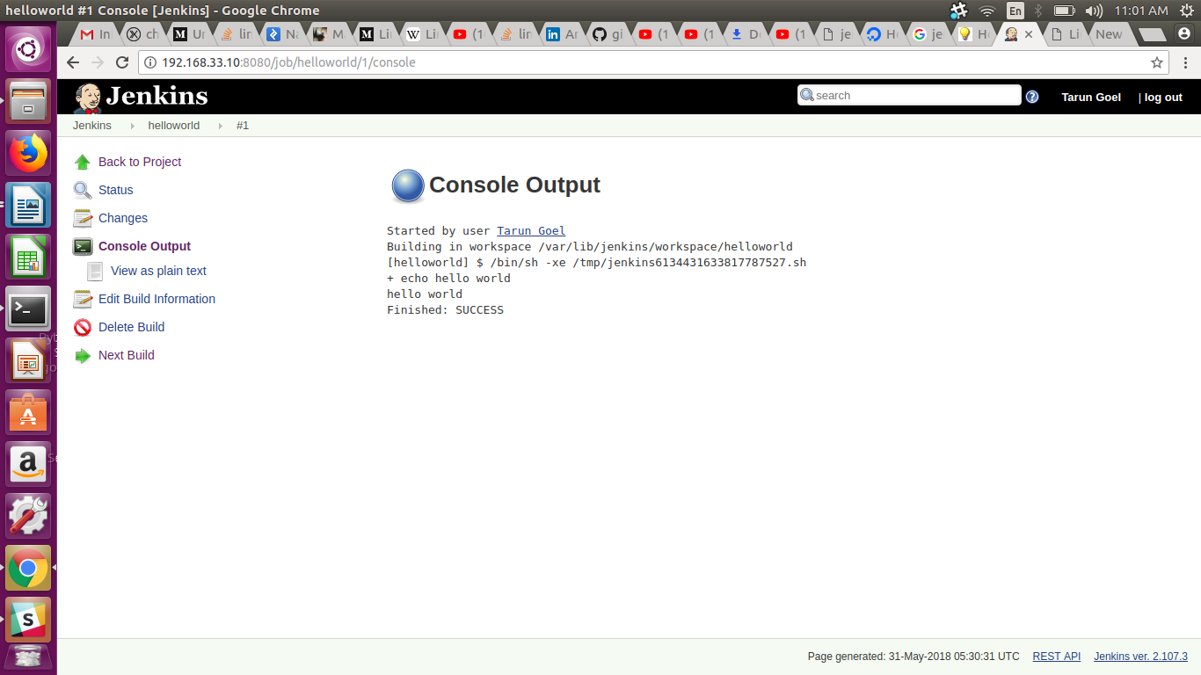

- Create a freestyle job to which take absolute path of a directory then
  - List all files and directories inside that.
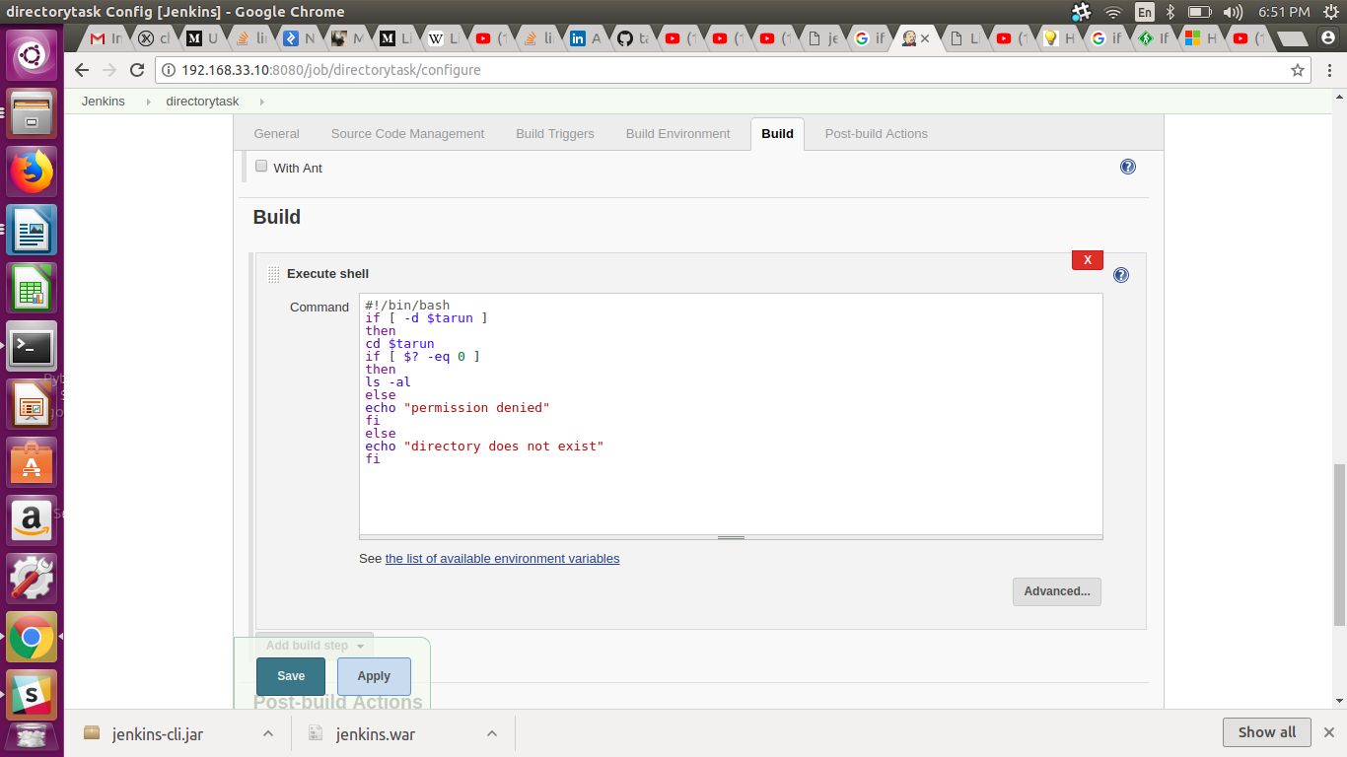

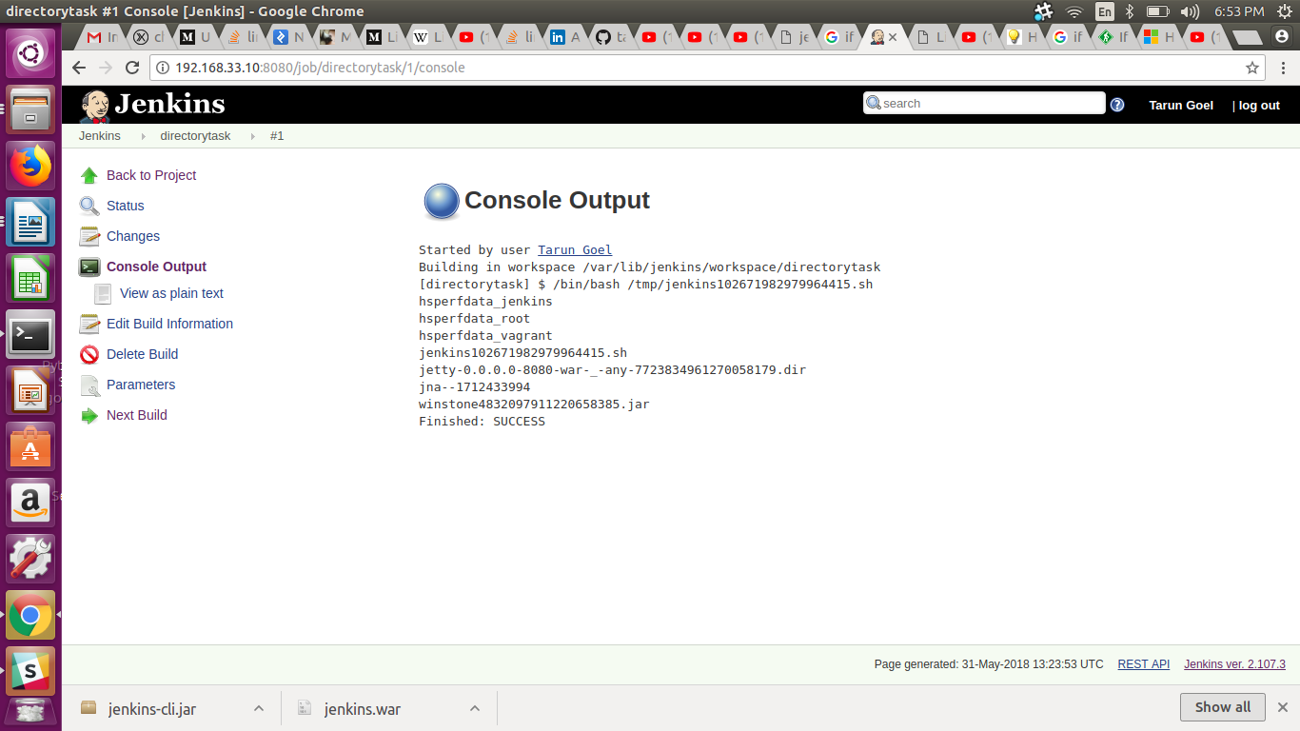
  - Print a message "drectory not exist" if directory doesn't exist on file system
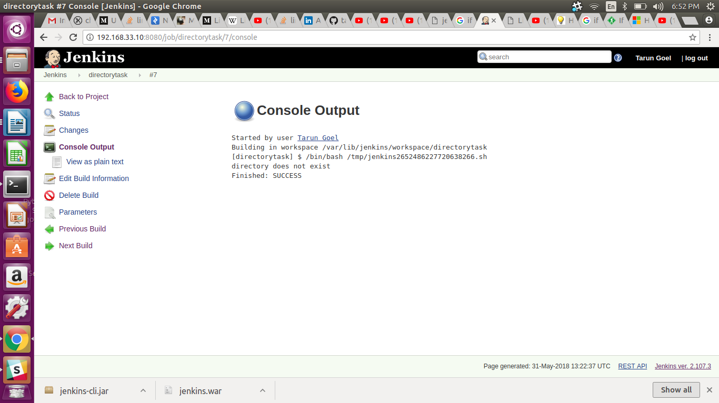

  - Print "Inappropriate permissions" if you don't have permissions to list files.
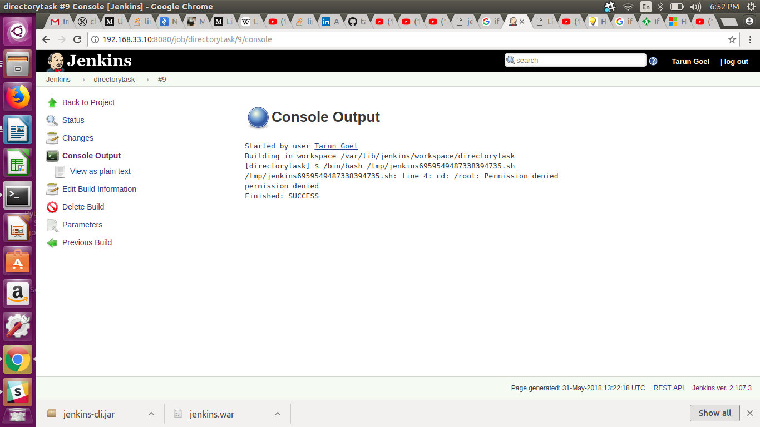

- Create a job to clone your jenkins repo and cat a file from it.

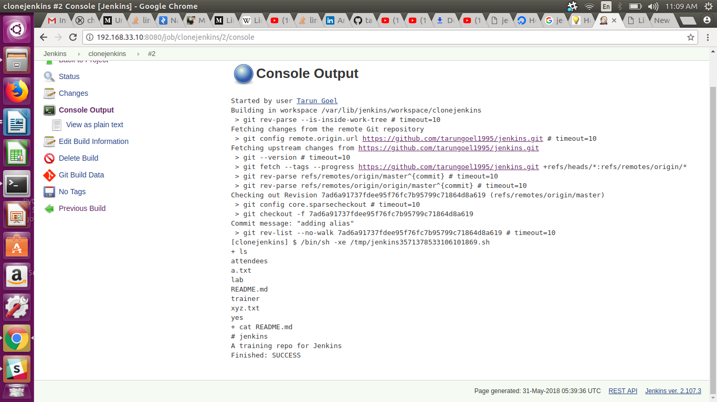

- Assignment4:
- Increase and decrease number of executors and observe the build queue.
Increase executers to 7.
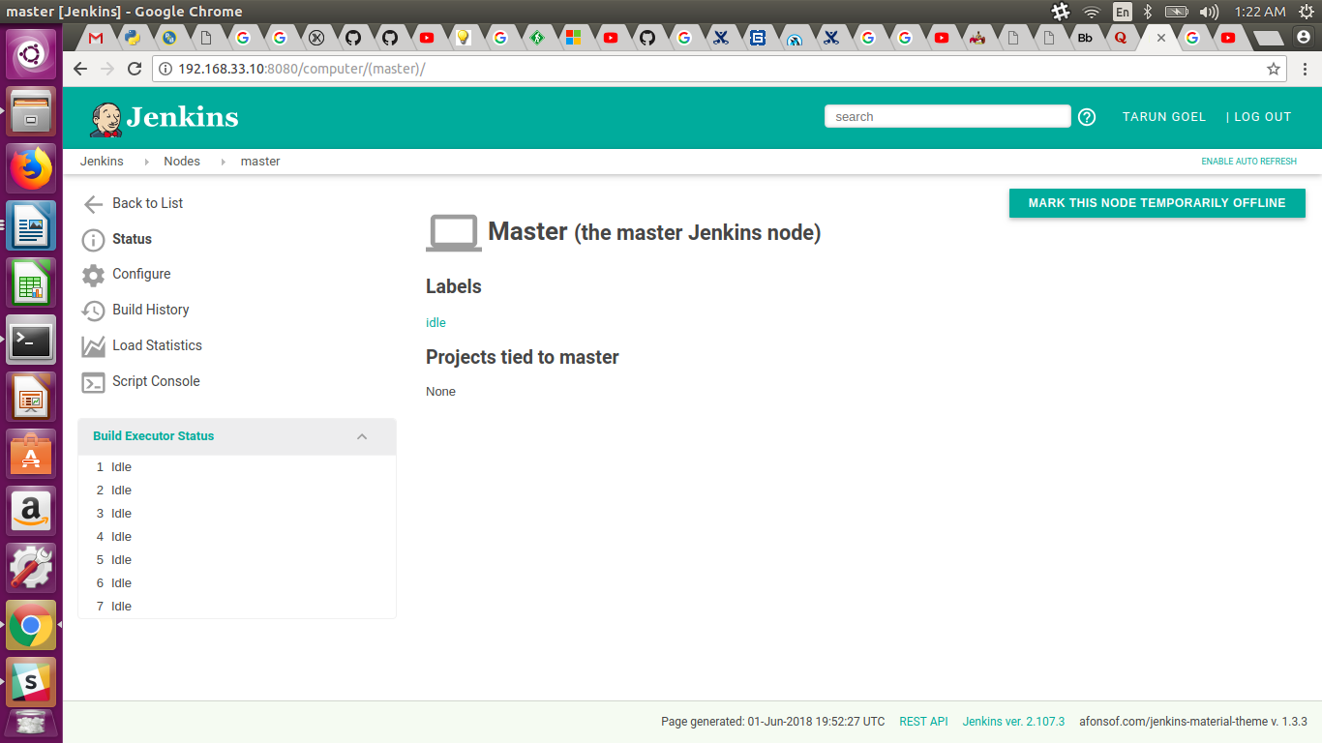
Decrease the size to 4
